Rotary’s District 5110, Announces New #TRYROTARY Contest
CENTRAL, WESTERN AND SOUTHERN OR, Feb. 1, 2026 – From February through April, Rotary District 5110 in Oregon and Northern California is inviting community individuals who are not currently members to visit a Rotary club and learn how to give back to their community. When interested persons attend a meeting or event, they can enter the #Try Rotary Contest, with a chance to win a grand prize and other giveaways.
Rotary District 5110, which includes much of southern and central Oregon, plus two communities in northern California, includes more than 60 clubs and 2700 members. Many of them may be among friends and neighbors. There are 530 Rotary Districts and 46,000 clubs worldwide.
Every visit to a club meeting or event counts toward a contest entry. The drawing will be held May 1 and announced on social media and at the Rotary District conference, May 15-17, in Cottage Grove.
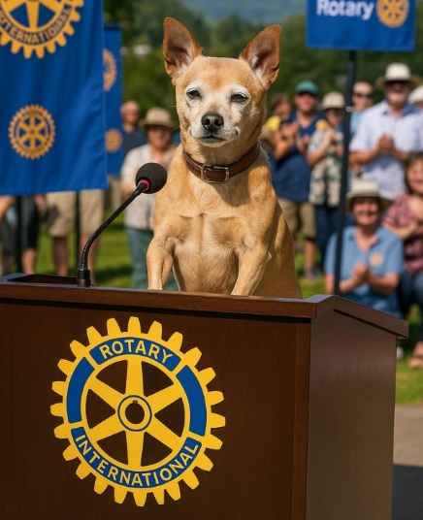
To enter #Try Rotary, visit the District 5110 website at https://rotarydistrict5110.com/try-rotary/. Find a district map with locations and contacts for area clubs Interested persons can also contact a local member Rotarian and be invited to attend a meeting or event.
Attendees can enter the contest through the same website or by posting a photo to social media and using the hashtag #tryrotary. Additional entries are awarded to attendees who post a photo with the Rotary mascot, Yoda (pictured) or his mascot plushy, found at every club meeting.
At a Rotary event or meeting, clubs share their service projects and programs, which provide a positive impact on local communities and the world. Attendees also hear from notable speakers addressing local, regional, or international issues.
Prizes awarded include a grand prize of tickets for either the Shakespeare Arts Festival in Ashland, or the Sunriver Music Festival in Central Oregon, and a gift voucher for a hotel and restaurant in the area. Additional prizes include a myriad of Rotary swag and gift cards from restaurants, attractions, and other businesses.
For more information, contact District 5110 PI Chair Deanna Rivera at contact@southtownerotary.org. It’s a great time to #TRYROTARY!
#####

